Dispatch January 21, 2020 10:26 am

The Critic’s Notebook
by The Editors

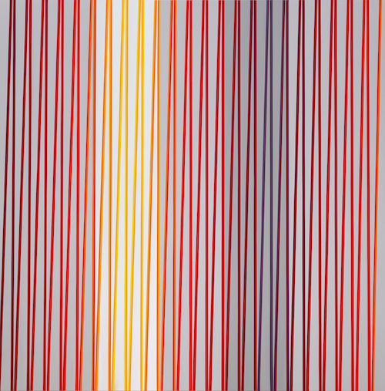
Gabriele Evertz, ZimZum, 2019, Acrylic on canvas, Minus Space.
“Gabriele Evertz: Exaltation, at Minus Space, Brooklyn (through February 29):
Gabriele Evertz, a scholar of color, uses contrasting and conflicting stripes of super-saturated pigments to dazzle the eye and accelerate the pulse. Her large works now at Brooklyn’s Minus Space may just be paint on canvas, but their effect in person is dizzying and disorienting as the eye looks up and down for solid ground. Colors melt into stripes of gray as surfaces seem to ripple in and out. For this current exhibition, Evertz relies on a combination of formula and improvisation to arrive at her final compositions. I especially enjoyed the lighter ones, where fields of white serve to cool her radiant color temperatures. Reproductions do not do these paintings justice. They need to be seen in person. —JP”

